***EXPERIMENT NO:-8***

**➢ AIM:** **To design and test multiplexer / de-multiplexer circuit**.

**➢ APPARATUS** : Logisim simulator.

**➢ THEORY:**

(It includes circuit description, truth table, circuit diagram and logical explanation.)

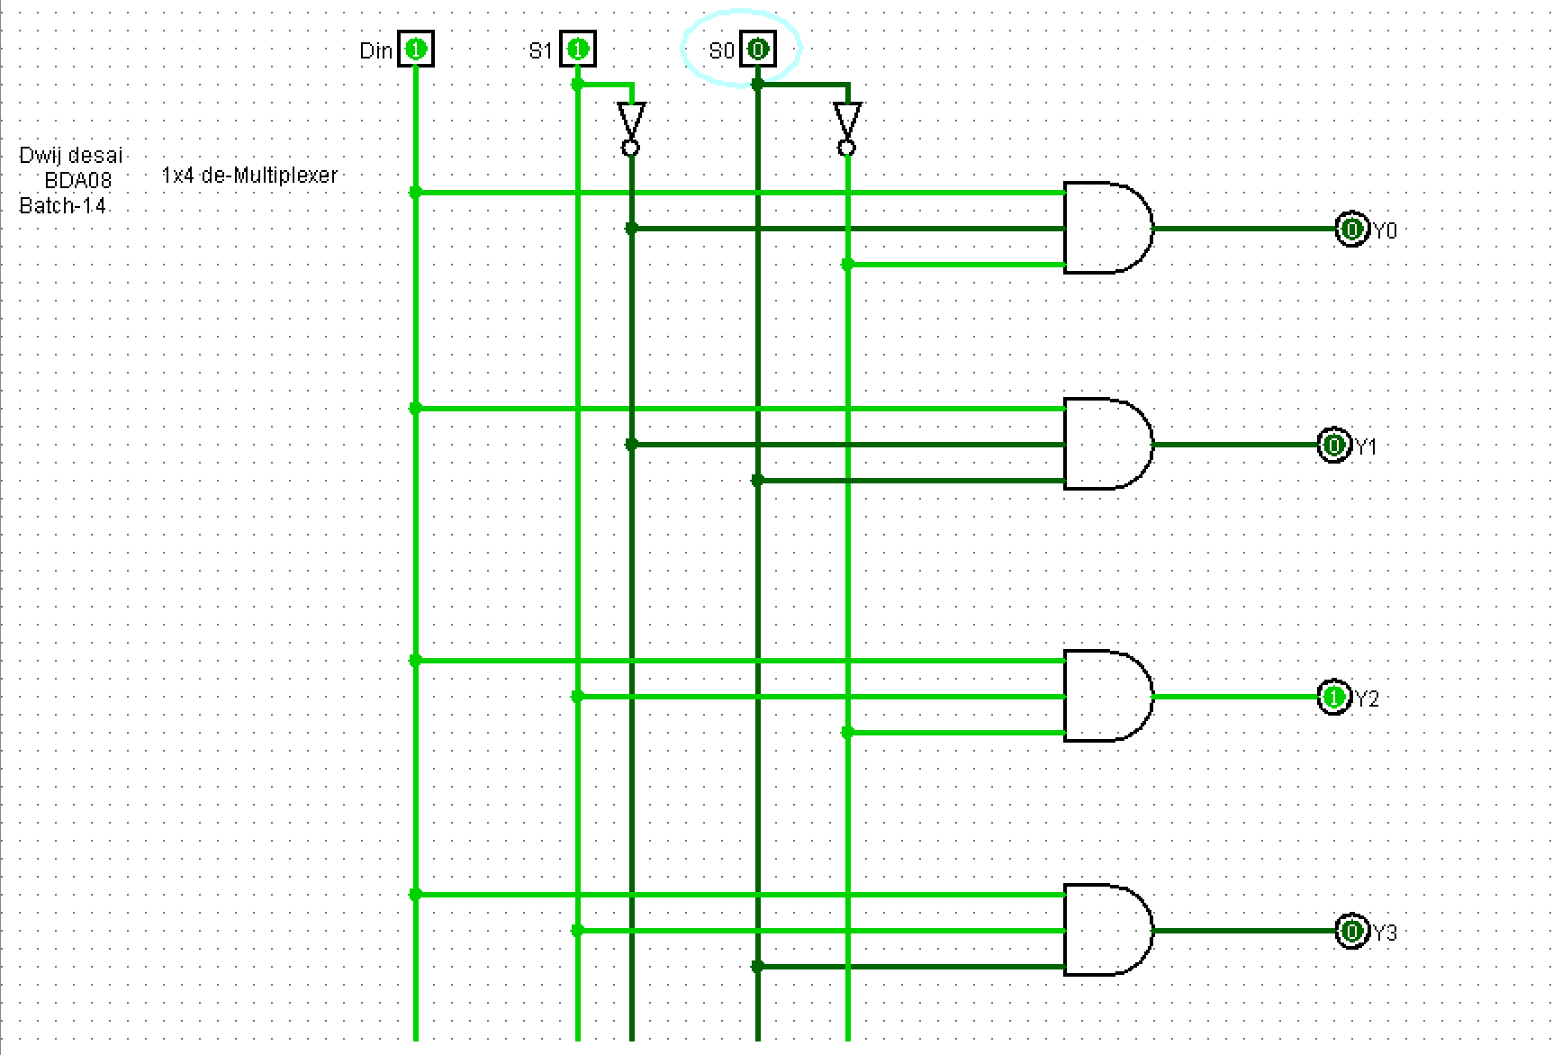

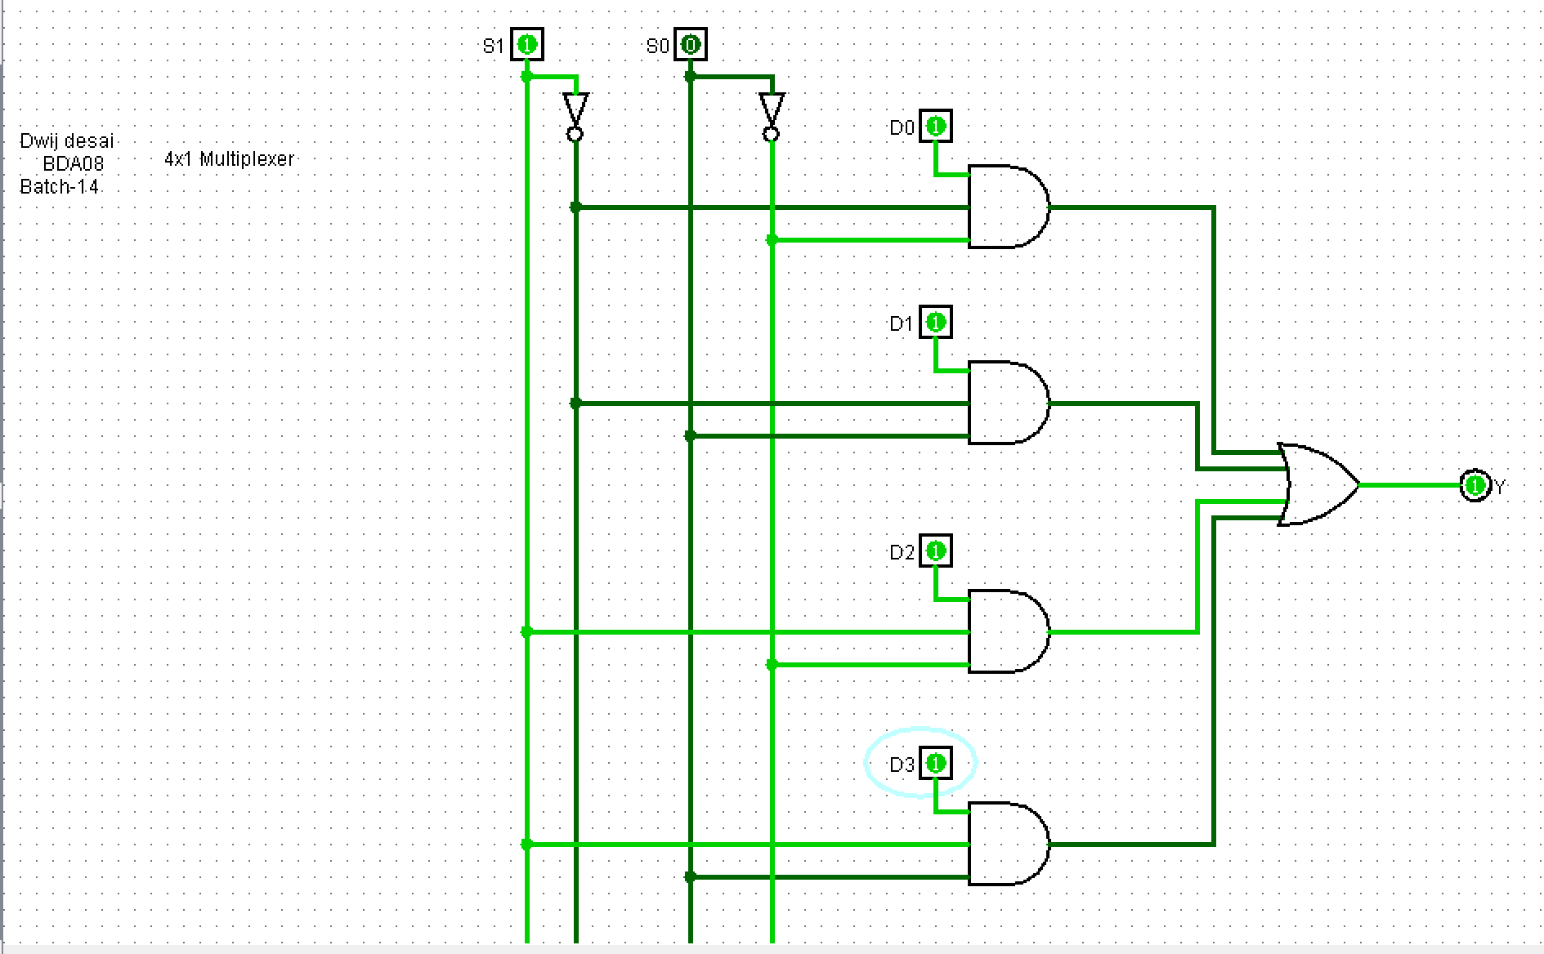

**➢ PROCEDURE:**

-Design the circuit using Truth Table and K-Map.

-Use Logisim simulator

-Take appropriate components/gates from part selection

- Place it on mains, define the respective values

-connect appropriate with inputs and output bits with the components/gates.

-Run the simulator and observe the results.

-Test the truth table of each converter circuit.

**➢ CONCLUSION:**

* Multiplexer takes 4 input and gives and gives 1 output so it’s name 4x1 Multiplexer.
* De-multiplexer takes 1 input and give 4 output hence the name 1x4 De-multiplexer,  
  it helps user to control the output of certain component.

**➢ Exercise:**

Implement an 8x1 Mux by using 4x1 Mux

